|  |  |  |  |
| --- | --- | --- | --- |
| **Ex. No. 08** | **YACC Calculator** | | |
| Date of Exercise | _____________ | Date of Output Verification | _________ |

**Question**

Write a YACC program to evaluate arithmetic expression

**Program**

%{

/* C declarations used in actions */

#include <stdio.h>

%}

/* yacc definitions */

%union {int a_number;}

%start line

%type <a_number> exp term factor number digit

%%

/*descriptions of expected inputs corresponding actions (in C)*/

line : exp ';' '\n' {printf ("result is %d\n", $1);}

;

exp : term {$$ = $1;}

| exp '+' term {$$ = $1 + $3;}

| exp '-' term {$$ = $1 - $3;}

;

term : factor {$$ = $1;}

| term '*' factor {$$ = $1 * $3;}

| term '/' factor {$$ = $1 / $3;}

;

factor : number {$$ = $1;}

| '(' exp ')' {$$ = $2;}

;

number : digit {$$ = $1;}

| number digit {$$ = $1*10 + $2;}

;

digit : '0' {$$ = 0;}

| '1' {$$ = 1;}

| '2' {$$ = 2;}

| '3' {$$ = 3;}

| '4' {$$ = 4;}

| '5' {$$ = 5;}

| '6' {$$ = 6;}

| '7' {$$ = 7;}

| '8' {$$ = 8;}

| '9' {$$ = 9;}

;

%% /* C code */

int main (void)

{return yyparse ( );}

int yylex (void)

{return getchar ( );}

void yyerror (char *s)

{ fprintf (stderr, "%s\n", s);}

**Input**

7+8

**Output**

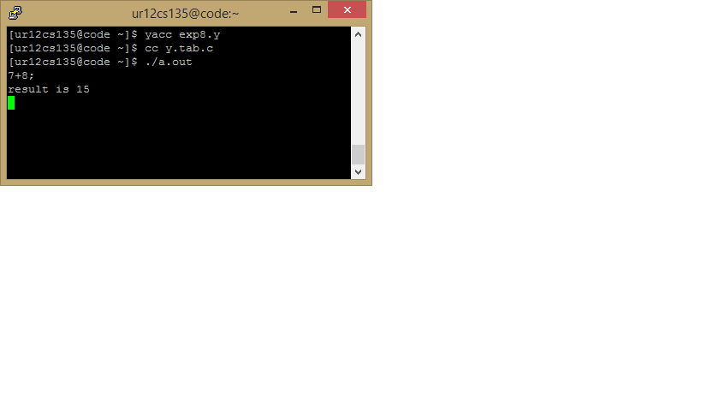

**Result**

Implementation of Calculator in YACC is successfully done.

[Signature of the Staff In-charge]

Name of the Staff In – charge: Mr. Jeban Chandir Moses

Date: _____________